DNS Record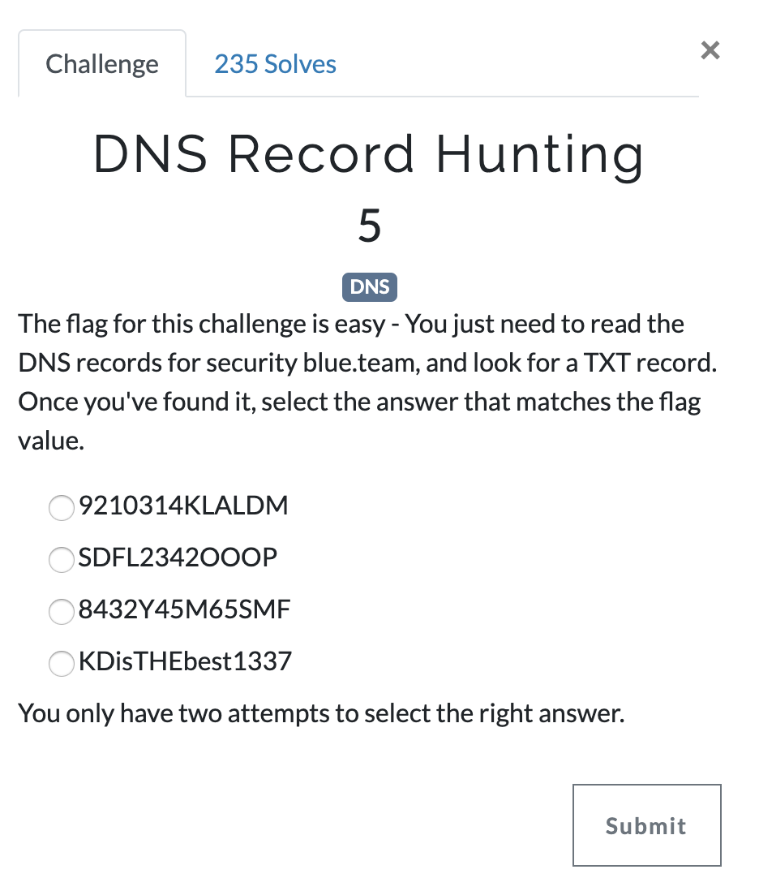
Answer: Using https://toolbox.googleapps.com/apps/dig/ you can look up ANY record for securityblue.team. Below is the output. Flag:9210314KLALDM
The same thing can be done using the dig command in kali > dig -t any securityblue.team
